Chad Galloway

CST-250 Programming in C# II

Grand Canyon University

Oct. 26th, 2025

Milestone 1

Files

<https://github.com/CGalloway3/CST-250-Projects/tree/master/Milestone%201>

Video

<https://www.loom.com/share/37fd6d8df8644eaeba4991f78dd9d9d0>

UML Class Diagram

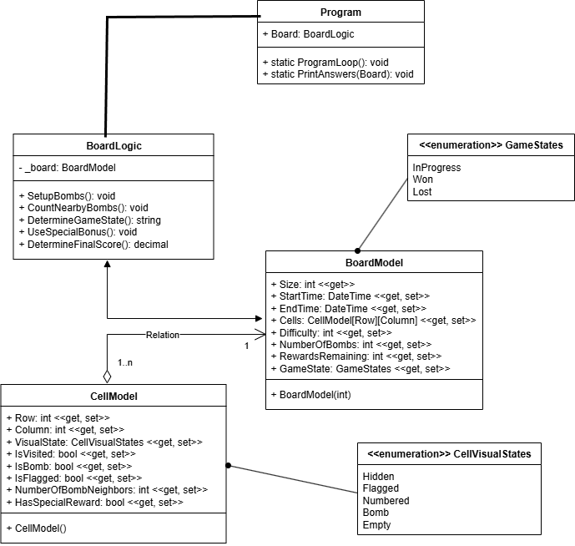

Figure 1: UML Class Diagram

Figure 1 is a screen shot of the milestone 1 class diagrams for the minesweeper application.

**Screen Shots**

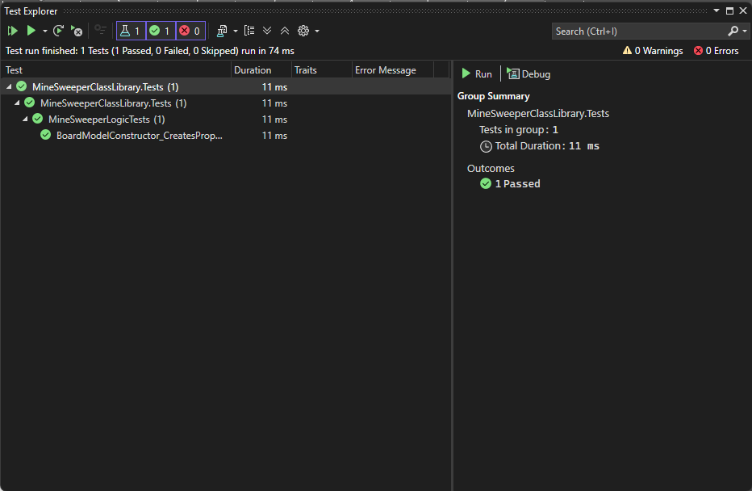

Figure 2: Screenshot of successful unit test

Figure 2 is a screen shot of my first unit test being successfully completed.

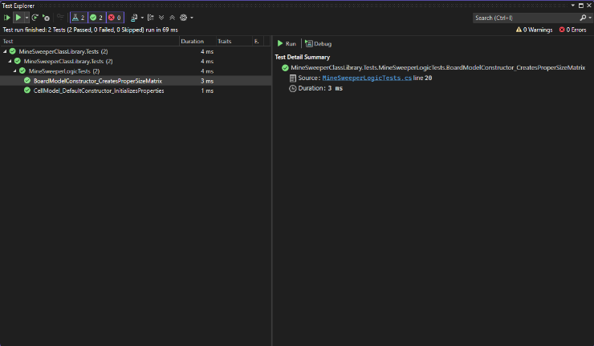

Figure 3: Screenshot of second unit test passing

Figure 3 is a screen shot of the test explorer after complete and passing the second unit test for the project.

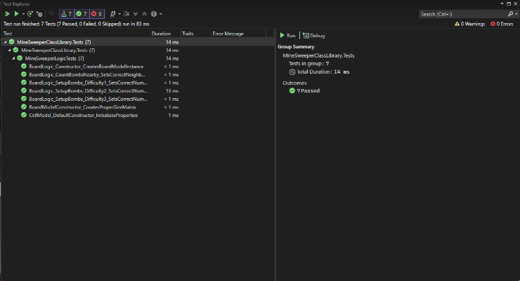

Figure 4: Final test explorer screenshot

Figure 4 is a screenshot of the final running of my unit tests in the test explorer for the milestone 1 project. I tested the model’s constructors for the cells and the board models. Tested the instance of the board being created and the bombs being placed based on difficulty and finally the count nearby bombs feature.

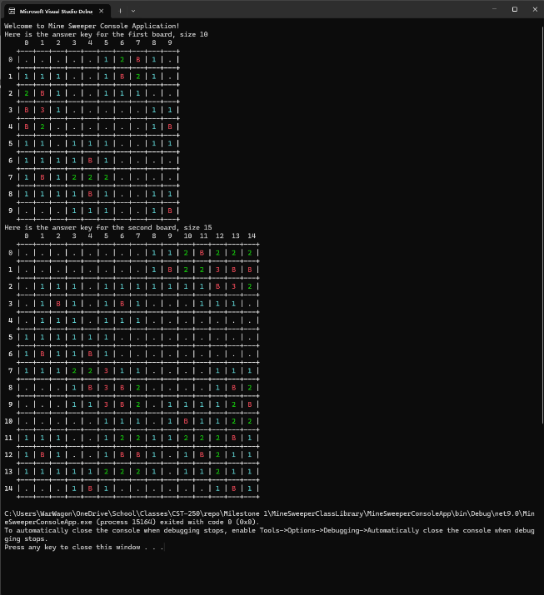

Figure 5: Application run

Figure 5 is a screenshot of the application running at difficulty 1

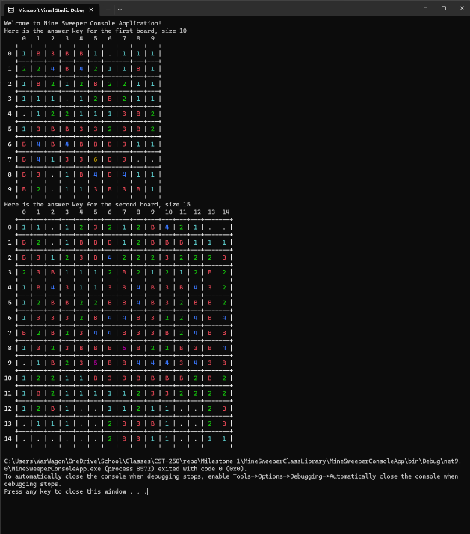

Figure 6: Application run

Figure 6 is a screenshot of the application running at difficulty 3

Summary of key concepts

The key concepts in programming demonstrated by this milestone are n layer architecture and the separation of concerns. The concept of running unit tests on code is also a part of this milestone. The test-driven development workflows cycle of red -> green -> refactor is demonstrated within the unit test concept. This milestone also demonstrates the pillars of abstraction, inheritance, and polymorphism.